1.Bitcoin Price

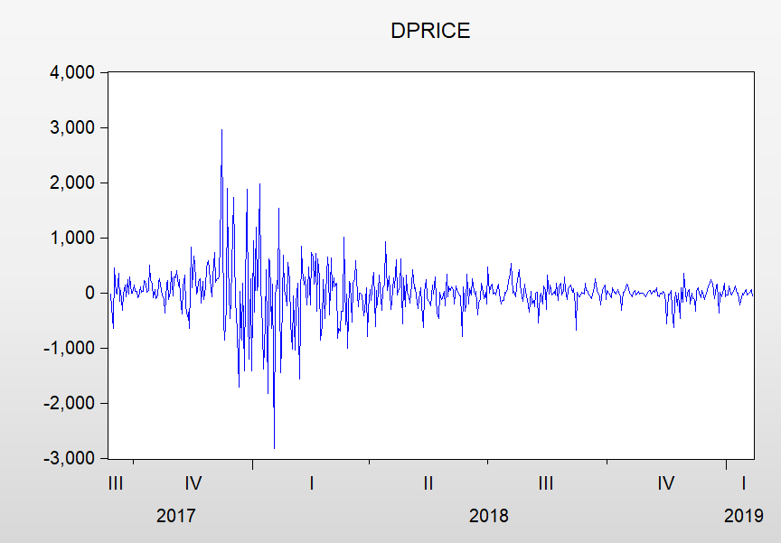

2. ADF Test

2.1 dif_log_price

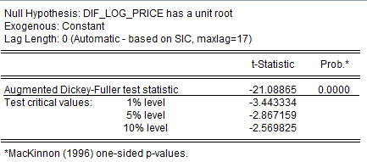

Dif_log_price is stationary

2.2.dprice

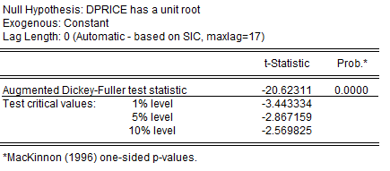

dprice is stationary

3. Linear regression

Use dprice ~ d1 d2 d3…

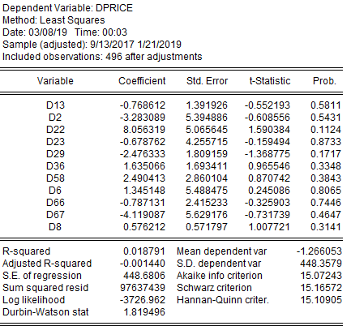

Non linear relationship

4. Granger Causality Test

**4.1.diff_log_price**

Granger Cause

<0.05 D2/D6/D8/D9/D13/D22/D33/D29/D36/D37/D54/D55/D58/D63/D66/D67/D68/D85/D93

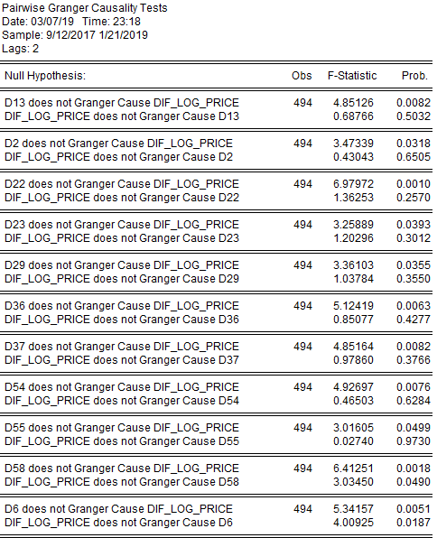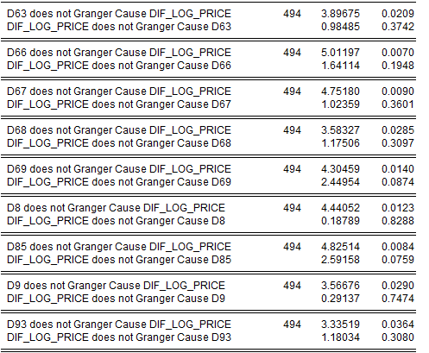

<0.1

D16/D17/D19/D26/D33/D65/D78/D86

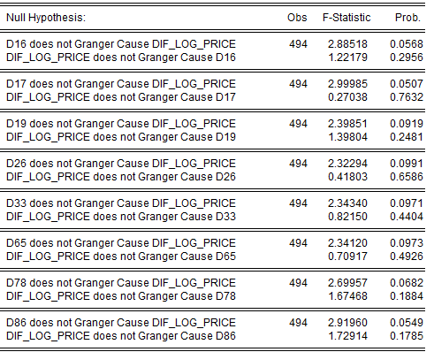

**4.2.dprice**

Granger Cause

<0.05

D13/D14/D16/D19/D2/D22/D23/D29/D32/D33/D35/D36/D39/D49/D58/D59/D6/D66/D67/D69/D77/D79/D8/D99/D100

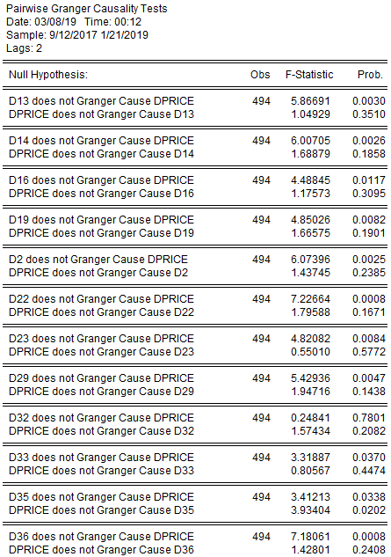 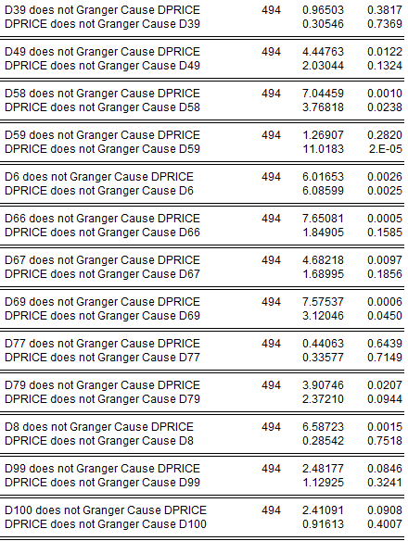

<0.1

D1/D17/D41/D62/D78/D93/D94

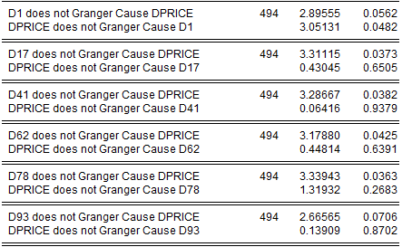

**4.3.Common factors:**

**D13/D2/D22/D23/D29/D36/D58/D6/D66/D67/D69/D8**

**D17/D93**

So to reduce the numbers of factors,I use their common factors

5. VAR Model

5.1. dif_log_price

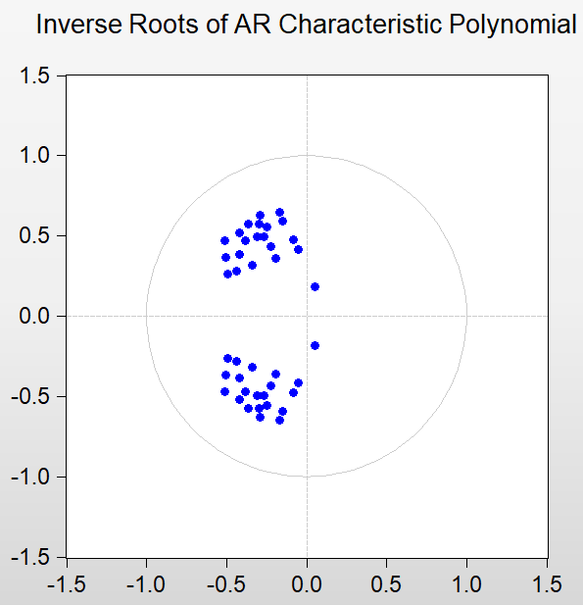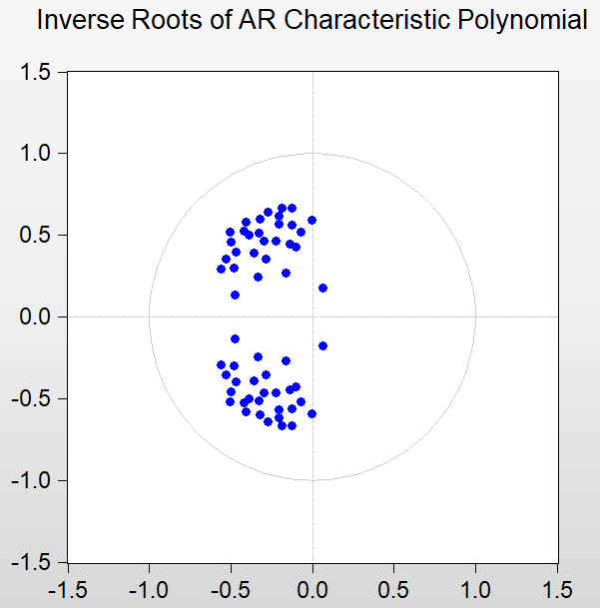

AR Graph(Grange<0.05) AR Graph(Granger<0.1)

Because it is currently a limit of 30 endogenous variables in a VAR.So we use Granger Causality Test at first. Then go back to test the correctness.

The model is stationary. So we can use Granger Causality Test！

5.2 dprice

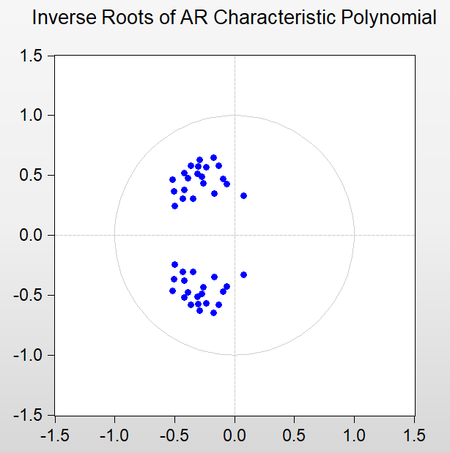

AR Graph(Grange<0.05)

The model is stationary. So we can use Granger Causality Test！

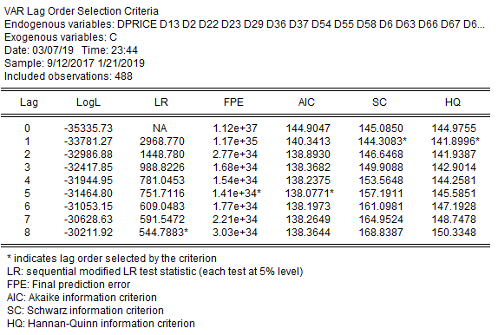

According to AIC lag order=5. So we can use dprice rather than dif_log_price

to show the lag-period influence.

6. Cointegration Test

6.1.Dif_log_price:

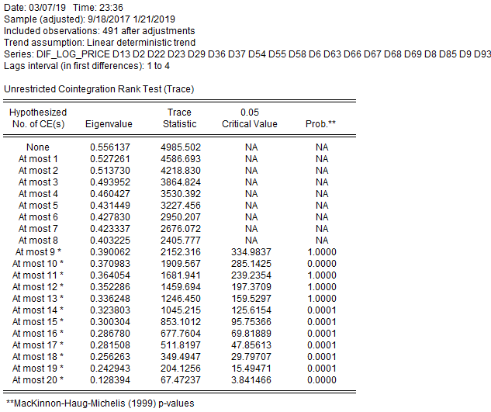

Have cointegrate relationship

6.2.dprice:

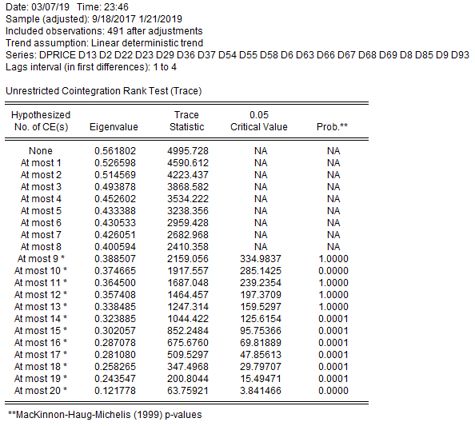

Have cointegrate relationship

7.PCA result is not useful, after 10 PCs can only over 85% significant level.

8.Impulse Responses(dprice)

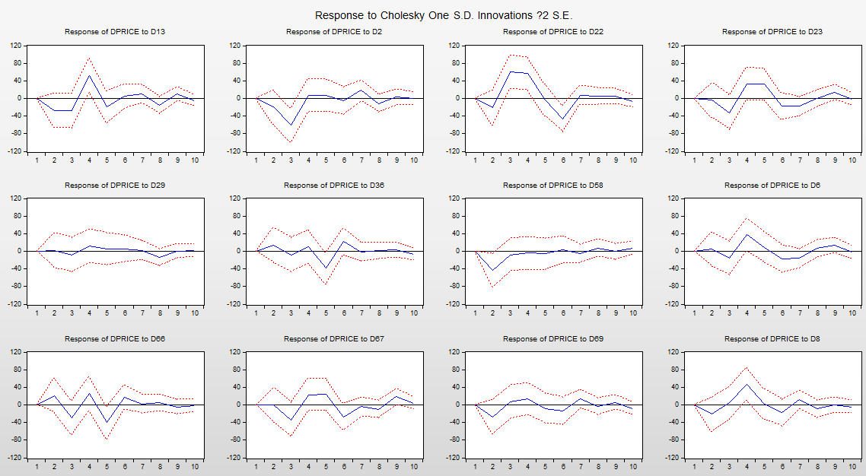

Can read the fluctuation direction from the graph.

Finally converge to zero.

9.Variance Decomposition(dprice)

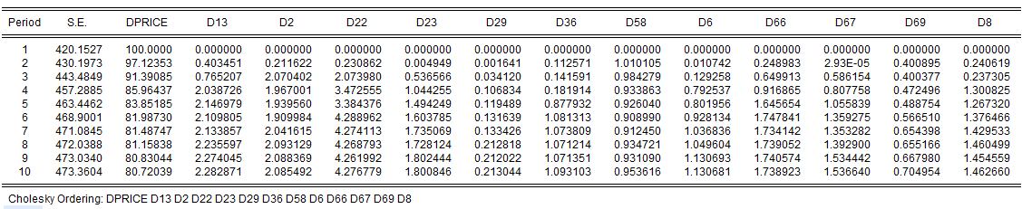

Most of the variance is caused by the price fluctuation itself

Until 10 periods,D22 cause 4.27%,D13 and D2 cause 2%